

Service Delivery Manager

WebAssembly changes

Version #1.0

Release Date: December 2024



**Copyright**

This publication was written and produced by WellSky Corporation.

© 2024 WellSky Corporation

All Rights Reserved

No part of this document may be reproduced or transmitted in any form or by any means, electronic or mechanical, including photocopying, recording, or by any storage or retrieval system, without permission in writing from WellSky Corporation.

Printed in the United States – 2024

**Contact WellSky Support**

Please be sure to identify your full name and the name of your organization in voicemails or emails.

* **Client Resource Center 24/7:** <https://wellsky.my.site.com/AgingandDisability>. New to the Client Resource Center? Click the Request Account link to set up your account.
* **Client Experience Support: 855-WELLSKY**

WellSky Corporation

11300 Switzer Road

Overland Park, KS 66210

<http://www.wellsky.com>

**Contents**

Introduction 3

Clear browser Cache 3

For Edge users 3

For Chrome users 4

Work Queue / Dashboard changes 5

New consumer record fields 6

Gender Identity 6

RUCA is Rural 6

Right-click formatting 6

Export grid file location 7

New service upload options 7

# Introduction

Welcome to the WebAssembly version of WellSky’s Service Delivery Manager. This guide outlines the changes you will see in the solution and includes a few steps you need to take the first time you log in.

**IMPORTANT –** Please take a moment to review the document before you begin using Service Delivery Manager. Some actions must be taken before your first login.

# Clear browser Cache

After your organization has updated to the WebAssembly version of Service Delivery Manager ***before logging into the solution for the first time***, follow these guidelines to clear your browser cache.

## For Edge users

1. Open the **Edge** browser.
2. Click the **Ellipsis** (three dots) in the upper right corner of the Edge window.
3. Click Settings.
4. In the Search field, type “cache”
5. In the Clear browsing data section, click **Choose what to clear**.

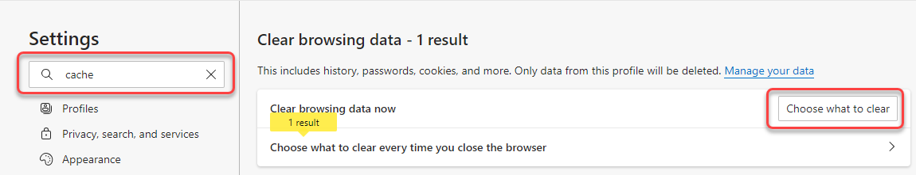

1. In the Time Rangefield, select **All time** and verify that all options are selected.
2. Click **Clear Now**.

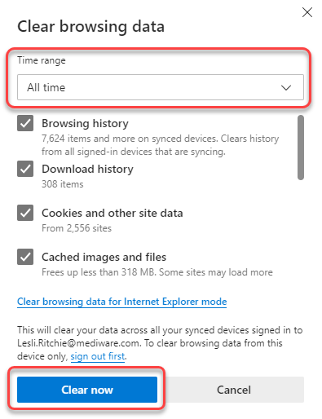

## For Chrome users

1. Open the **Chrome** browser.
2. Click the **Ellipsis** (three dots) in the upper right corner of the Chrome window.
3. Click **Clear Browsing data...**
4. On the **Basic** tab, change Time Range to **All Time**.
5. Click **Clear data**.

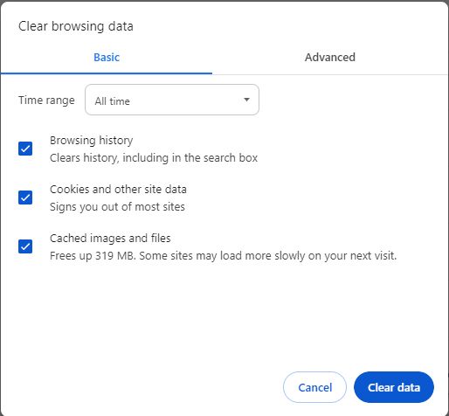

# Work Queue / Dashboard changes

The look and feel of the Work Queue have changed. Widgets that were previously displayed as tiles are now in a tabular format located across the top of the screen.

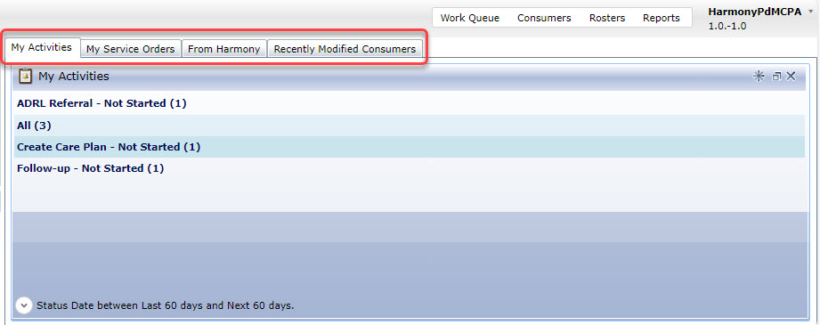

# New consumer record fields

Two fields have been added to the consumer record.

## Gender Identity

Gender Identity is defined as the gender with which the consumer identifies.

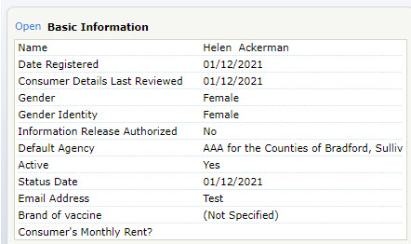

## RUCA is Rural

This field is used with NAPIS reporting to designate if the consumer lives in a rural area. This designation is based on the residence ZIP Code.

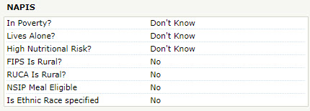

# Right-click formatting

Previously, you could right-click to display a menu and select Cut, Copy, Paste, or Select All. In the new version, you must use keyboard shortcuts for these commands.

* Cut = Ctrl+X
* Copy = Ctrl+C
* Paste = Ctrl+V
* Select All = Ctrl+A

# Export grid file location

When you export grids, the export is automatically saved to your local **Downloads** folder. If you’ve changed the default location on your workstation for downloads, the file will be downloaded to that location, rather than the Downloads folder.

# New service upload options

Previously, when a service delivery file was uploaded, the data in the file was overwritten for matching deliveries. Now, you have the option to add service delivery units (Accrue) or replace existing units with the new information from the uploaded .csv file.

1. In the **Quick Links** section, click **Uploads**.
2. Click **Add New** in the **Uploads** toolbar.
3. In the **Accrue Units** option, do one of the following:
   1. **Select Accrue Units**: Delivery records that match existing data elements are added to the matching delivery record and the existing units on the delivery are not overwritten. Data elements include the following: Service month/year, care program, agency, provider, sub-provider, service, subservice, Fund ID, and site.
   2. **Do not select Accrue Units**: Delivery records that match the service delivery data elements will replace the existing delivery with the new unit count/daily units found in the .csv file.

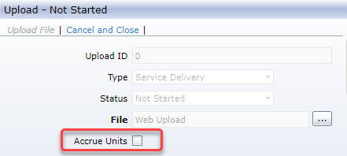

1. The remaining process is the same.